Nominee Information
Name: ____________________________________ Home/Mobile Phone: __________________________
Address: ________________________________________ Work Phone: __________________________
__________________________________ E-mail: ______________________________________
Company: ______________________ # of employees: ____ Position/Job Title: ___________________
For Profit or Nonprofit? ____________________________ Parish: ______________________________
CRITERIA:
Nominee must be currently employed and working within the boundaries of the Archdiocese of Saint Paul and Minneapolis, comprised of the 12‐county greater Twin Cities metropolitan area.
Nominee must be a practicing Catholic and an active member of his/her parish, which must be located in the Archdiocese of Saint Paul and Minneapolis.
Nominee must be active in at least two parish or spiritually-based community programs or organizations.
Nominee should be in a leadership position at his/her place of business (owner, president/VP, director, manager, supervisor, etc.)
Describe the work for which you are nominating this individual. Please give specific examples of the nominee’s
faith-based leadership. Examples should demonstrate how the nominee exceeds the leadership expectations of his/her job description, and may include: treatment of employees and/or shareholders, values-based wages and benefits, role modeling or mentoring. Use additional pages, if necessary.

Describe the nominee’s activities/role within his/her workplace, giving examples of how his/her faith affects his/her leadership. For example: Has the nominee faced an ethical dilemma/adversity in his/her work environment and resolved the issue? In what ways does he/she go above and beyond to help those in need? How does being a Catholic directly influence the decisions he/she makes at work? Use additional pages, if necessary.

List major parish, archdiocesan, spiritually based and/or non-church community organizations to which the nominee belongs, as well as his/her role. Use additional pages, if necessary.

ADDITIONAL INFORMATION
Include any additional information about how the nominee serves the community. Include his/her personal qualities and background, special interests, family or education that supports your nomination. Use additional pages, if necessary.

*Photos and additional information supporting this nomination may be included with the application. (If submitting via email, please include supporting information as attachments.) Materials submitted with the nomination will not be returned. *Photos attached: Yes

Nominator Information
Name: ____________________________________ Home/Mobile Phone: __________________________
Address: __________________________________ Work Phone: _________________________________
__________________________________ E-mail: ______________________________________
Employer/Occupation: ____________________________________________________________________
How long and in what capacity you have known this nominee?: _________________________________

Applications should be submitted to:
Archdiocese of St. Paul and Minneapolis/The Catholic Spirit
Attention: Leading With Faith
777 Forest Street
St. Paul, MN 55106
Or email to: wiebuschm@archspm.org
Applications are accepted continuously.
To be considered for recognition in 2018, nomination forms must be received by May 4, 2018.
Awards will be presented at a luncheon banquet on Friday, August 10, 2018
University St Thomas – North James B. Woulfe Alumni Hall - Anderson Student Center
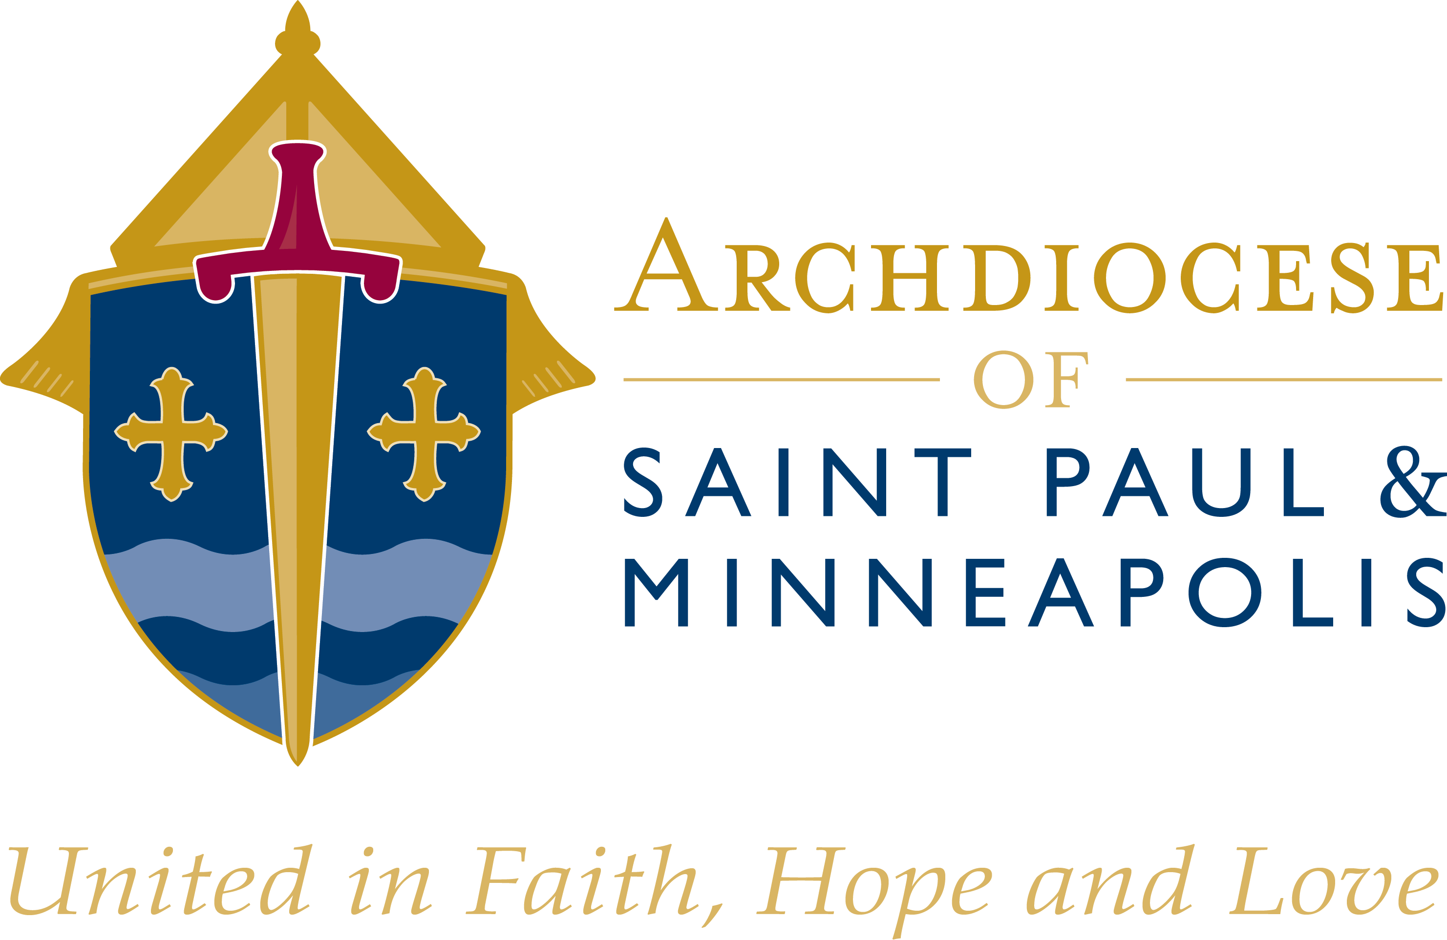
Presented by:

